NAME: MOHANA RAM S

ROOL NO: 713322AD068

DEPT: B.TECH AI&DS “B”

**TASK:1**

**TOPIC: FIVE REAL WORLD APPLICATION OF DATA SCIENCE**

Data science has a wide range of real-world applications across industries. Here are five key examples:

**1. Healthcare & Medical Diagnosis**

* Predicting diseases using machine learning
* Personalized treatment plans based on patient data.
* Predicting outbreaks of diseases using epidemiological data.

**2. Finance & Fraud Detection**

* Fraud detection in credit card transactions using anomaly detection.
* Algorithmic trading to optimize stock market investments.
* Risk assessment for loans and insurance policies.

**3. E-commerce & Recommendation Systems**

* Personalized product recommendations (e.g., Amazon, Netflix, Spotify).
* Customer sentiment analysis from reviews and social media.
* Dynamic pricing strategies based on demand and competition.

**4. Self-Driving Cars & Autonomous Systems**

* Object detection and recognition for autonomous vehicles.
* Predictive maintenance for vehicle components.
* Route optimization and traffic pattern analysis.

**5. Marketing & Customer Analytics**

* Customer segmentation for targeted advertising.
* Social media trend analysis for brand positioning.

**TASK:2**

**TOPIC: DIAGRAM FOR AIML AND DEEP LEARNING**

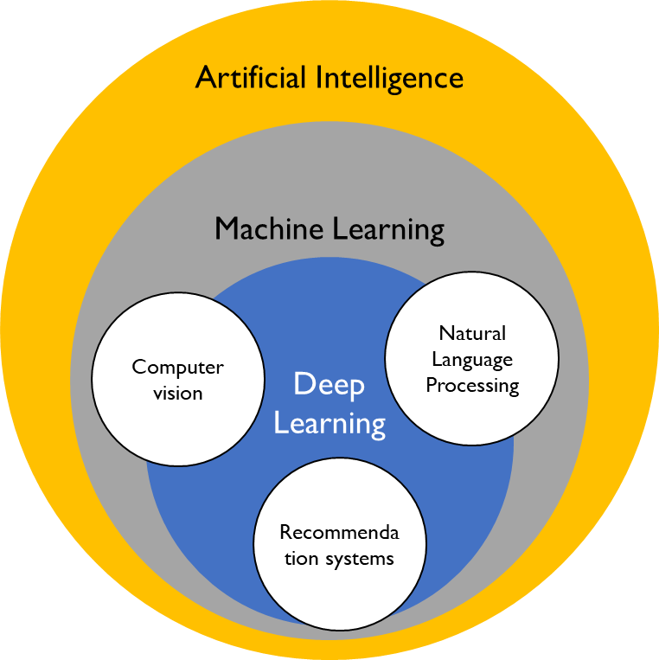

**ARTIFICIAL INTELLIGENCE:**

Artificial intelligence is a field of science concerned with building computers and machines that can reason, learn, and act in such a way that would normally require human intelligence or that involves data whose scale exceeds what humans can analyze.

AI is a broad field that encompasses many different disciplines, including computer science, data analytics and statistics, hardware and software engineering, linguistics, neuroscience, and even philosophy and psychology.

On an operational level for business use, AI is a set of technologies that are based primarily on machine learning and deep learning, used for data analytics, predictions and forecasting, object categorization, natural language processing, recommendations, intelligent data retrieval, and more.

**MACHINE LEARNING:**

Machine Learning (ML) is a branch of artificial intelligence (AI) that enables computers to learn from data and make predictions or decisions without being explicitly programmed. Instead of following fixed rules, ML algorithms identify patterns in data and improve their performance over time.

**TYPES OF Machine Learning:**

1. **Supervised Learning** – The algorithm learns from labeled data (e.g., spam detection, fraud detection).
2. **Unsupervised Learning** – The algorithm finds patterns in unlabeled data (e.g., customer segmentation, anomaly detection).
3. **Reinforcement Learning** – The model learns by interacting with an environment and receiving rewards or penalties (e.g., self-driving cars, robotics).

**DEEP LEARNING:**

Deep Learning is a subset of machine learning that uses artificial neural networks to process and analyze large amounts of data. These neural networks are designed to mimic the way the human brain processes information, enabling computers to recognize patterns, make decisions, and improve performance over time.

**TASK:3**

**TOPIC: RESEARCH AND LIST 3KEY ROLES & RESPONSIBILITIES**

**ChatGPT said:**

In data science, there are several key roles, each with specific responsibilities. Here are three important ones:

**1. Data Scientist**

**Responsibilities:**

* Analyzing large datasets to extract insights.
* Building and deploying machine learning models.
* Performing statistical analysis to support business decisions.
* Communicating findings through data visualization and reports.
* Working with stakeholders to solve business problems using data.

**2. Data Engineer**

**Responsibilities:**

* Designing and maintaining data pipelines and infrastructure.
* Ensuring data quality, integrity, and availability.
* Optimizing data storage and retrieval processes.
* Working with cloud platforms (AWS, Azure, GCP) for data storage and processing.
* Supporting data scientists by providing clean, well-structured data.

**3. Machine Learning Engineer**

**Responsibilities:**

* Developing and deploying machine learning models at scale.
* Optimizing model performance and efficiency.
* Implementing MLOps (Machine Learning Operations) for continuous deployment.
* Integrating AI solutions into applications and systems.
* Monitoring and retraining models to ensure accuracy over time.

**TASK:4**

**TOPIC: DATA SCIENCE LIFE CYCLE**

**Healthcare & Medical Diagnosis in Data Science**

Data science and machine learning are transforming healthcare by improving disease diagnosis, treatment planning, and patient care. By analyzing large medical datasets, AI-powered systems can assist doctors in making more accurate and faster diagnoses.

**Key Applications:**

* **Medical Imaging Analysis** – AI detects diseases like cancer from X-rays, MRIs, and CT scans.
* **Predictive Analytics** – Machine learning predicts diseases based on patient history, helping in early diagnosis .
* **Personalized Medicine** – AI tailors treatments based on a patient’s genetic data, improving effectiveness.
* **Drug Discovery** – AI accelerates drug development by analyzing molecular structures and predicting potential medicines.
* **Remote Patient Monitoring** – Wearable devices track health metrics and alert doctors about abnormalities (e.g., Apple Watch detecting heart issues).

**Impact:**

These advancements enhance accuracy, efficiency, and accessibility in healthcare, ultimately saving lives and reducing costs.

**TASK:5**

**TOPIC: DATA SCIENCE ETHICS DISCUSSION**

**Discussion on Data Science Ethics**

As data science continues to evolve, ethical considerations play a crucial role in ensuring that AI and data-driven decisions are fair, transparent, and beneficial to society. Below are some key ethical concerns in data science:

**1. Data Privacy & Security**

* Collecting, storing, and processing user data must be done with consent.
* GDPR (General Data Protection Regulation) and other regulations protect user privacy.
* Data breaches and unauthorized access can lead to identity theft and misuse of personal information.

**2. Bias & Fairness**

* AI models can inherit biases from historical data, leading to discrimination (e.g., biased hiring algorithms).
* Ensuring fairness in AI requires diverse datasets and unbiased training methods.

**3. Transparency & Explainability**

* Many AI models, especially deep learning, are considered "black boxes" with unclear decision-making processes.
* Explainable AI (XAI) helps in understanding how models arrive at their predictions, which is crucial for trust.

**4. Accountability & Responsibility**

* Who is responsible when an AI system makes a harmful or incorrect decision.
* Ethical AI development requires clear policies on accountability.

**5. Ethical Use of AI & Data**

* AI should not be used for unethical purposes like surveillance, deepfake creation, or manipulating elections.
* Ethical guidelines, such as those from AI organizations, help regulate the responsible use of AI.